Homework #6

1. (20 points) QuickSort: array A=<22, 98, 17, 6, 34>.
(a) (10 points) Illustrate the operation of QuickSort using Fig. 7.1 on p. 172 as a model for the operation of Partition.
(b) (10 points) How many swaps are performed by QuickSort to sort array A? How does this compare with the number of swaps used by HeadSort for this same array.

Ans:
(a) Firstly, apply QuickSort(A, 1, 5) on A, there Partition(A,1,5) performs 4 swaps and return 4. Then, continue to apply QuickSort on the partitions, QuickSort(A,1,3) will execute Partition(A,1,3) which performs 1 swap and return 1, and QuickSort(A,5,5) will do nothing. After that, QuickSort(A,1,0) and QuickSort(A,2,3) will be executed. QuickSort(A,2,3) will execute Partition(A,2,3) which takes 2 swaps and return 3, while QuickSort(A,1,0) does nothing. The QuickSort(A,1,5) will finish after QuickSort(A,2,2) and QuickSort(A,4,3) finished with no effect.
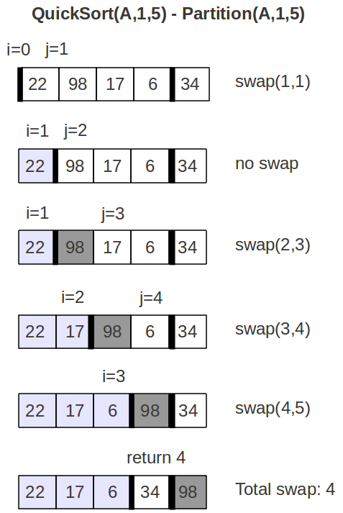
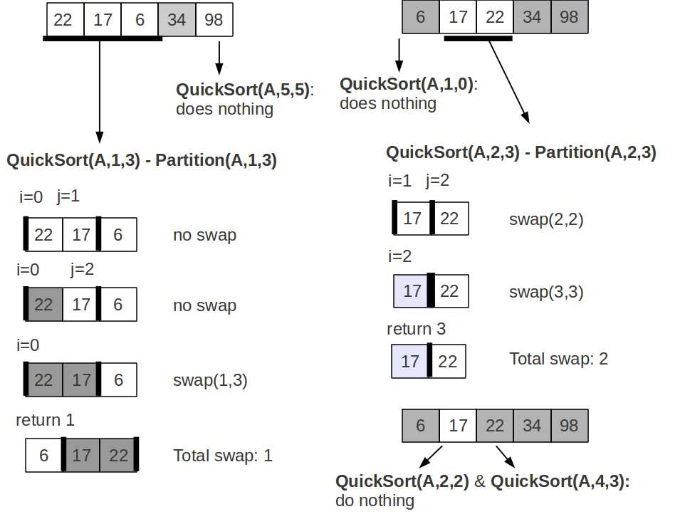

b) The total swap number of QuickSort(A,1,5) is 4+1+2 = 7. Compared to HeapSort on A which has 8 swaps, the performance of QuickSort is better than that of HeapSort.

2. (20 points) QuickSort Analysis: Textbook Exercise 7.4-2 on p. 184.
Ans:
Method1:
The best-case time for procedure QUICKSORT on an input of size n is:

We guess we obtain:

Letwe have:

Let F'(q)=0, we know that F(q) will get the minimum value when q=(n-1)/2. Therefore,

since we can pick the constant c small enough so that the termwill be dominated by theterm. Thus,

3. (20 points) Suppose that the PARTITION procedure of QUICKSORT is modified to always use the first element as the pivot:
(a) Provide a worst-case example for QUICKSORT.
(b) Provide a best-case example for QUICKSORT.
Ans:
(a) Worst-case: <3,1,2>

(b) Best-case: <2, 3, 1>

4. (40 points) Hoare Partition: Textbook Prob. 7-1 on p. 185-186, parts(a)-(d)
Ans:
(a) Here, we only show the illustration of HOARE-PARTITION(A,1,12), the procedure has 3 iterations of the while loop and breaks the loop at i=10 and j=9, finally returns 9:
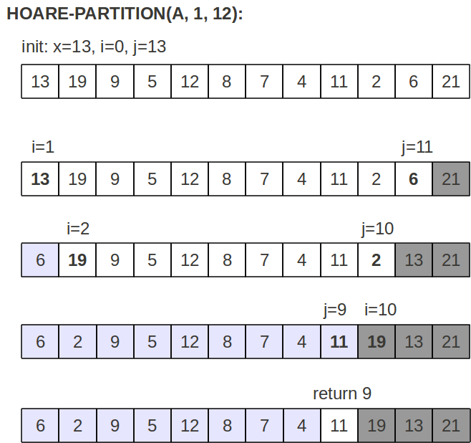

(b) Assume we apply HOARE-PARTITION on the array A[p..r] where r > p since A[p..r] contains at least two elements, and x=A[p] is the pivot value.
The initial state of the array should be as follows:
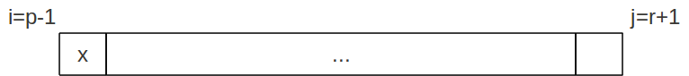

According to the code, we know that j decreases from j=r+1, and this decreasing at least terminates at j=p since A[p]=x. Similarly, the increasing of i terminates after increasing 1. After the initial loop, the starting state of the array in any loop can be of the following form:
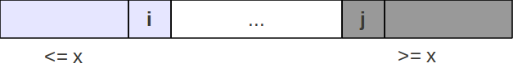

Note that the light-shadowed part is the smaller part in where all elements are smaller or equal to x, correspondingly the heavy-shadowed part is the larger part in where all elements are greater or equal to x. This is satisfied because of line 5-10.
Therefore, for each iteration of the while loop, it guarantees that the decreasing of j (line 5-7) will stop at the rightmost element of the smaller part even if the all elements in the middle are greater than x. Similarly, i cannot exceed the leftmost element of the larger part. And we know that the size of each parts is at least 1 since r > p, so we can conclude that the decreasing j can not be smaller than p, and the increasing i can not be greater than r for r > p.

(c) We already prove that j >= p in problem (b). Now we only need to prove j<r:
We find j will decrease if A[j]>x, there is two cases in the first loop:
- If A[j=r] > x: j will decrease which means j<r.
- If A[j=r] <= x: j will not decrease in the first iteration, then j=r. Due to line 8-10, i will stop at i=p since A[p]=x>=x, then i=p. Therefore, we know that i=p<r=j. According to line 11-13, the while loop will continue, which means in the second iteration j will decrease at least 1 anyway. So, j becomes smaller than r in the second iteration.

(d) As shown in (b), when the procedure terminates there are only two parts of the array: the smaller part (A[k], k=p,...,i) and the larger part (A[k], k=j,...,r), where i>=j (due to line 11-13). We know that elements in larger part should be greater or equal to x and elements in smaller part should be smaller or equal to x, that is, elements of A[p..j] ( subset of the smaller part) are smaller or equal to elements of A[j+1..r] (subset of the larger part).

